**Button controlled LED**

**Theory Concept Used:**

The LED turns on when the button is pushed and turns off when the button is released.

# Learning and Observations:

Following observations were recorded during the experiment:

* The LED turns on when the input from the button is HIGH and turns of when it is LOW.
* The button needs to be connected to the ground to give LOW input when the button is not pressed.

# Problems and Troubleshooting:

The problem faced while performing the experiment was that the program compiled and uploaded to the board successfully but the LED didn’t glow. The problem was troubleshooted by replacing a connecting wire.

* Making a functional was a bit time taking as it becomes a bit confusing on arranging the wires.
* Minors errors showed up in the code during the test run, which was trouble shooted by the correcting the above port .

**Circuit Diagram :**

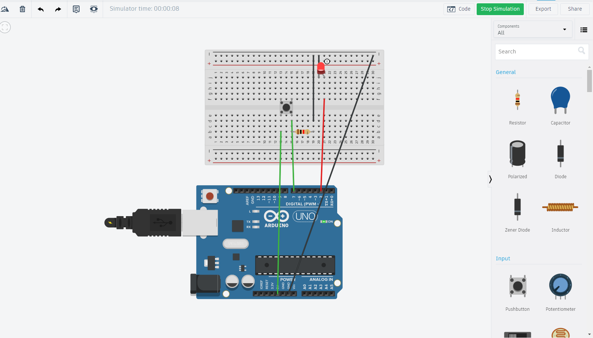

# Precautions:

The following precautions need to be considered while performing this experiment:

* The connections of the USB in both the PC and the ARDUINO UNO board should be snug.
* The USB ports of the PC and the ARDUINO UNO should be in a working

condition.

* The sketch should be logically and syntactically correct and germane to the experiment that needs to be performed.
* The correct serial port should be selected that is the one through which the ARDUINO UNO has been connected.
* Look for errors during compilation and upload of the executable to the

ARDUINO UNO.

* Disconnect the digital 1 and 0 pins while uploading the program to the board.
* Do not open more than one instance of the ARDUINO IDE at a time.

# Learning outcomes:

The various learnings as the outcome of performing the above-mentioned experiment are:

1. Use of the digitalRead() function.
2. Connecting a push button to take input and send it to ARDUINO.
3. I have learnt to use Arduino Board and how the code will work whenever the switch is pressed LED emits light.
4. How a circuit is placed on breadboard so that it can work properly.
5. Arduino board has Digital pins and Analog pins.
6. Digital pin provides Input as well as Output, but Analog pin provides only input.
7. The Arduino board has ~ sign in Digital pin side which is also known as Pulse Width Modulation(PWM)**.**
8. These pins help’s in getting Analog signals with digital means.